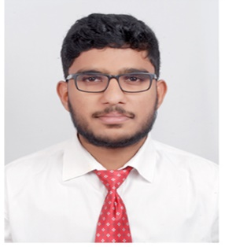

Dennis Prasad

Phone: 91-6362835176

Email address: dennisprasad67@gmail.com

#94, ‘Bethel’, Bharath Nagar, MS Palya, Vidyaranyapura PO-560097.

# Objective

To secure a challenging position where I can effectively contribute with my skills, and to work and learn in an environment that provides me with ample opportunities to update my skill set and achieve the goals of the company.

# Education

|  |  |  |  |  |
| --- | --- | --- | --- | --- |
| **QUALIFICATION** | **YEAR** | **INSTITUTION** | **BOARD** | **MARKS** |
|  |  |  |  |  |
| **BACHELOR OF TECHNOLOGY**  Electronics and  Communication  Engineering | 2020 | Sir M. Visvesvaraya  Institute of  Technology | Visvesvaraya  Technological  University,  Belagavi | CGPA-7.20 |
| **II PUC** | 2016 | Narayana PU College | Karnataka Board of  Pre-University  Education | 556/600  92.66% |
| **SSLC** | 2014 | St. Claret School | Karnataka  Secondary  Education  Examination Board | 594/625  95.04% |

Technical Skills

* Operating Systems (Windows and UNIX systems).
* Object Oriented Programming Languages: C++, Core Java and Python.
* Front-End Web Development (HTML5, CSS3, JavaScript ES6, JQuery).
* SQL based RDBMS like MySQL, SQLite, and PostgreSQL.
* NoSQL based DBMS like MongoDB.
* Familiar working on CLIs like Bash, Hyper, CMD and GitBash.
* Git, GitHub and Version Control including Local and Remote Repositories, Gitignore, Cloning, Branching and Merging.
* C, Embedded C.
* Automotive electronics, Verilog and VHDL fundamentals.

Internships and Projects

* “Responsive Website Development and Design” course offered by the University of London, Goldsmiths completed.
* Automotive Electronics training of 1 year done at KPIT.
* Four-week internship completed at The Overhaul Division, Hindustan Aeronautics Limited.
* Worked as part of a team on a mandatory academic project undertaken in the final semester on Fuel Automation systems.

# Out of Box Participations and Achievements

* Have participated in and won quiz competitions at various levels.
* Have hosted cultural events in school and college.
* Participated in district level Football meets multiple times.

# Personal Details

* DOB: 21st May 1998
* Gender: Male
* Languages known: English, Malayalam, Kannada, Hindi
* Father’s name: Prasad PK

# Declaration

I hereby declare that the information and details furnished above is true to the best of my knowledge.

Date: 23/12/2020

Place: Bangalore